What is lacking in life skills assessments in India?
By Daya Raja Sajeevan, Sreehari Ravindranath, Varsha Pillai: August 22, 2023

Research conducted on the value of life skills has demonstrated its short-term and long-term impact, such as reduced emotional distress and increased classroom engagement, well-being, and academic performance. Measuring such skills is important as it helps gauge the effectiveness of the intervention, identify students who may need extra support, and inform policy and practice.
The National Education Policy 2020 recognises and ably articulates the importance of life skills in the Indian education landscape, and eight Indian states have introduced curriculums and teacher training to promote the social and emotional skills of students and teachers. A contextual knowledge of the community needs to be at the core of life skills interventions since the various domains of life skills- such as communication, conflict resolution, and teamwork- are understood and operationalised differently across cultures.
- Lack of contextual knowledge and unconscious penalisation of students: Many life skills measurement tools such as the Devereux Early Childhood Assessment, Social-Emotional and Character Development Scale, and Social Skills Improvement System Rating Scales were developed in Western countries.
- Keeping student context at the centre: Knowing that every aspect of an assessment is influenced by context and local actualities, it is important to consider how they validate or invalidate a student’s abilities, identity, and culture. Intentionally creating space for different learning environments, multiple ways of demonstrating skill, and multiple types of evidence for skill improvement creates equitable and just assessment processes.
- The unlearning we need: Although the acknowledgement of the need for life skills in mainstream education in India is a laudable move, ensuring the just and equitable assessment of students’ skill requires unlearning and innovation on many fronts.
When assessment tools are developed with a grounded and intersectional lens, they can bring forth unique and nuanced insights and can ably help ascertain the effectiveness of different programmes. We must acknowledge that life skills assessment tools need to be contextually designed to ensure there are no chances of oversight or misinterpretation.
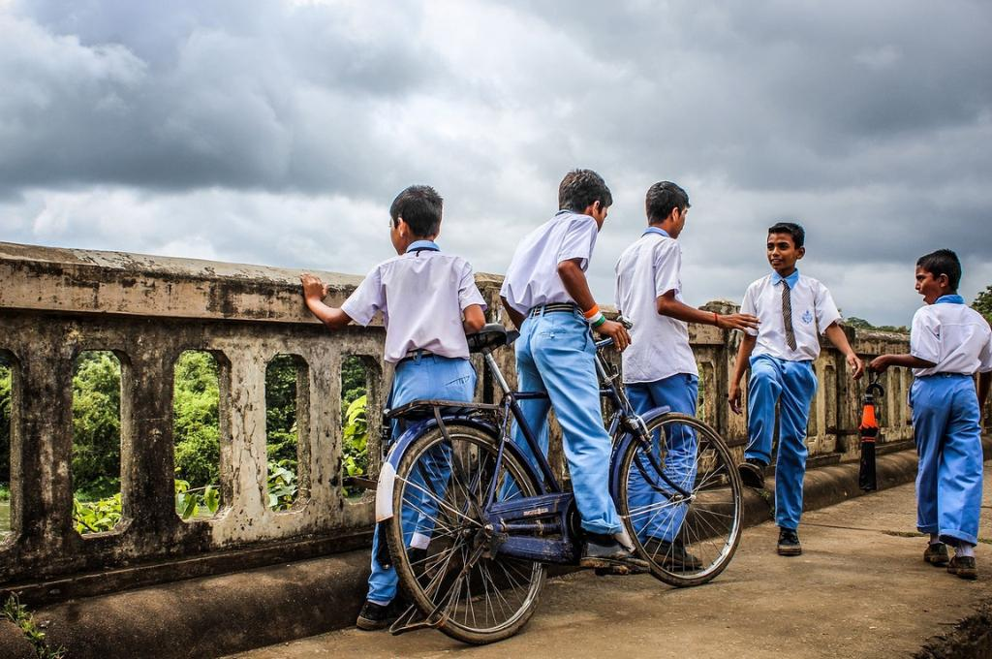

https://idronline.org/article/education/what-is-lacking-in-life-skills-assessments-in-india/

